RT50 Frame Shop ASM Line
Production instruction system
Screen Specifications

31 Aug. 2010

IC ENGINEERING CORPORATION
Approval | check | Making
 |  | Morita
Recode of Revisions

Version | Date of Revision | Details | Administrator | Approved
1 | 07/Sep./2010 | 02/Sep./2010 Review by screen review meeting with IMCT | Morita
The main menu
Click each of the buttons to move to individual screens.
Screen size is set to 1024 x 768.
1

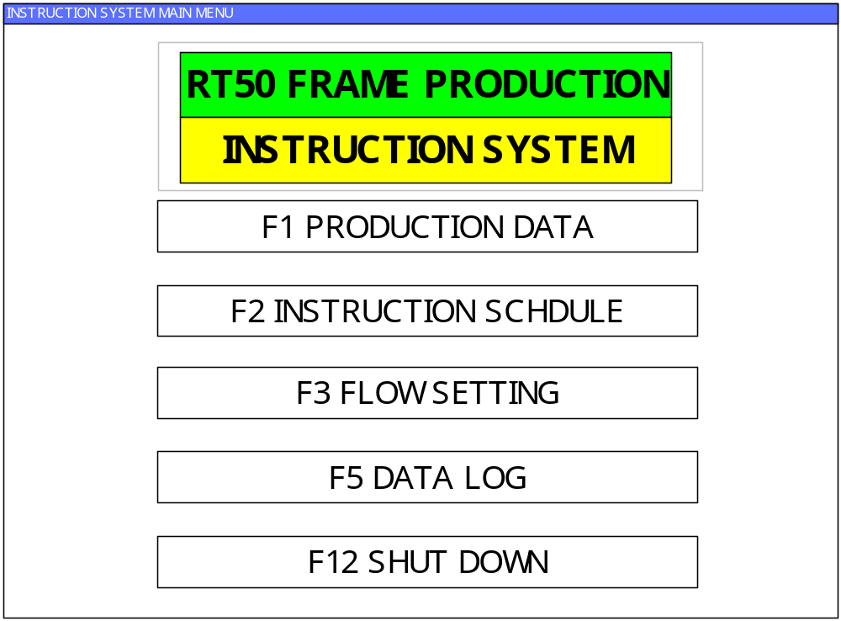 ＜Figure1･1･1＞

- F1 PRODUCTION DATA
Displays and allows editing of production data.
- F2 INSTRUCTION SCHDULE
Displays and allows editing of model instruction schedule.
- F3 FLOW SETTING
The flow of the production order of the module line is decided.
- F5 DATA LOG
Displays log data.
Allows operator to view operation log and data communication log.
- F12 SHUT DOWN
Shuts down the program.
Can also be used to shut down power to the computer terminal.

F1: PRODUCTION DATA
Displays and allows editing of the production data schedule.
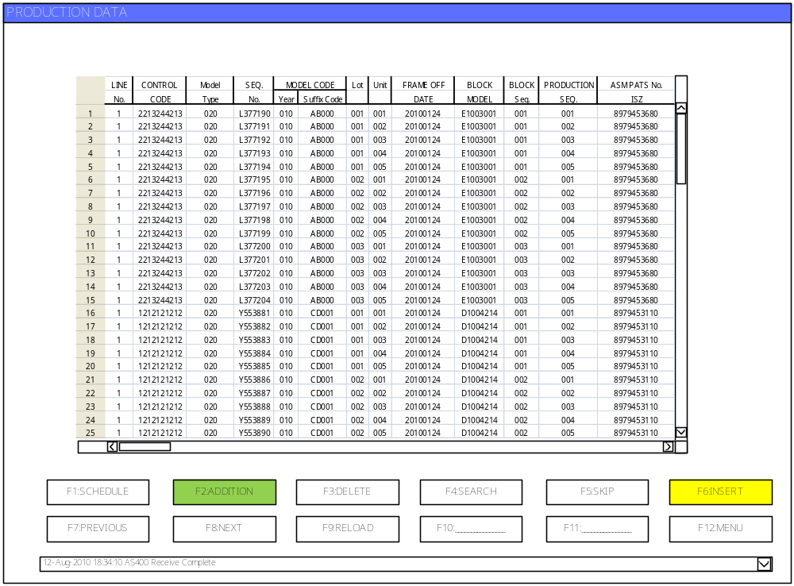
1
2

8
9
3
4

5

6
7
1
A
B

＜Figure1･2･1＞

All the scheduled auto instruction data is displayed.
Data is displayed in order of Production Date + SEQ No..
It is possible to display all data contained. Use the horizontal scroll bar to navigate around the screen.

- Line. No.
- Comntrol Code
- Model type
- Seq. No.
- Model Code : Year + Suffix Code
- Lot No.
- Unit No.
- Frame Off Date
- Block Model
- Block Seq.
- Production Seq.
- ASM Parts No. ISZ
- Spare

Note: PRODUCTION TIME data is stored in the database.

A: Message display window
Displays latest error message.

B: Error message history display
Click the combo box to display a log of the last 30 error messages.
Contains a combination of information from the data communication log and log data from the host computer (AS400).
The message display function is the same for all screens.
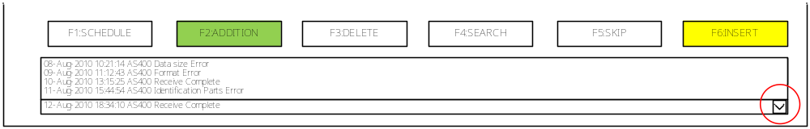
1

＜Figure1･2･2＞
- F1 SCHEDULE
The scheduled production instruction data is displayed.

- F2 ADDITION
Used to add schedules.
Select the appropriate line with the cursor and click the [F2: ADDITION] button.
＜Figure1･2･3＞
1

Clicking [F2：ADDITION] will bring up the data editing screen shown in <Figure 1･2･4>.

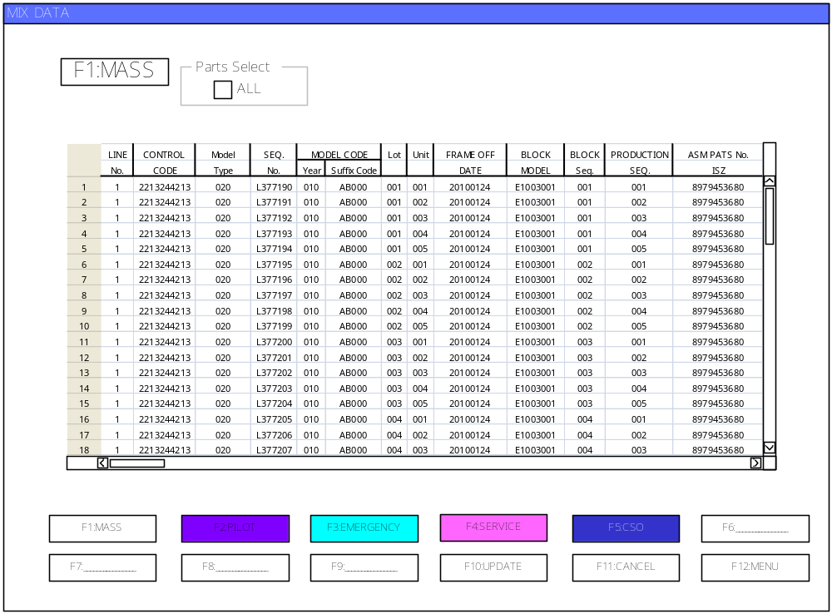
＜Figure1･2･4＞

One of the production instruction data that has divided into 5 pieces is selected.
- F1：MASS
- F2：PILOT
- F3：EMERGENCY
- F4：SERVICE
1
- F5：CSO

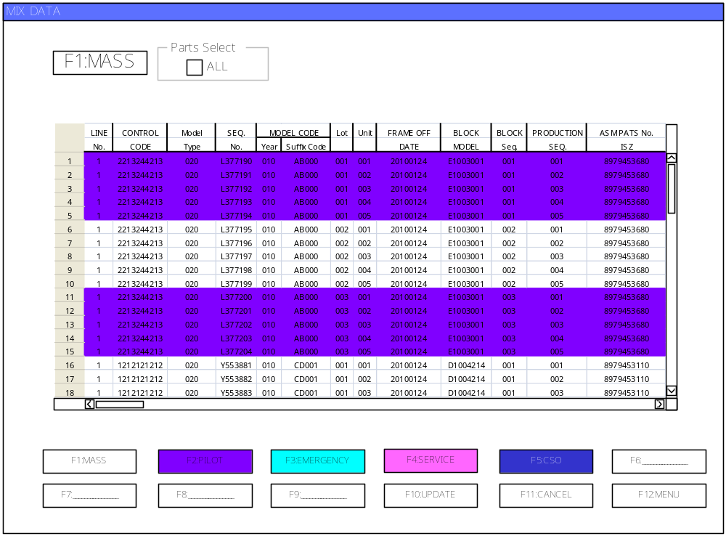＜Figure1･2･5＞

Next, the data produced with the selected production instruction data is selected.
"ALL" is clicked when producing by the order of the received production instruction data.
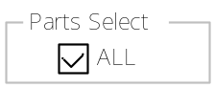

Clicking the [UPDATE] button will display the data list shown in＜Figure1･2･6＞.

Use the cursor to select where you want to insert the data and click the [F1: INSERT] button to insert the data in that position.
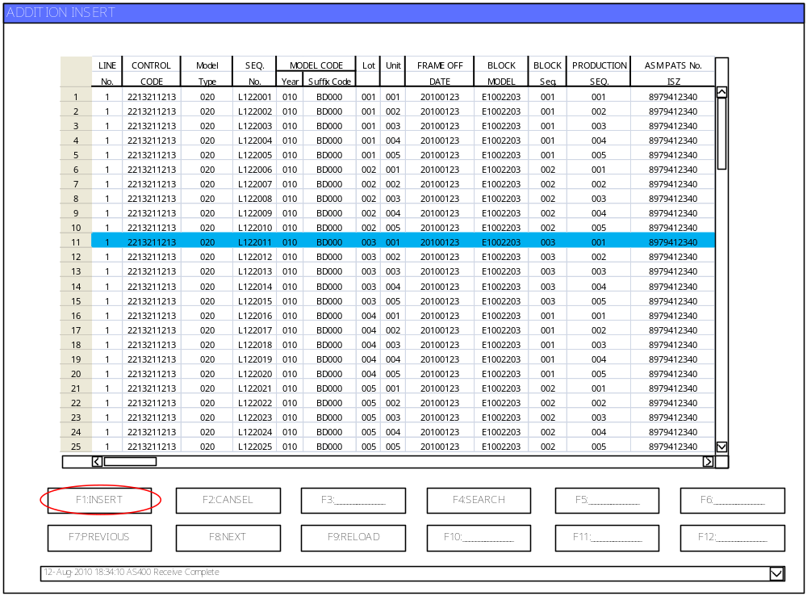

＜Figure1･2･6＞

Once you have completed the INSERT process, the screen will return to the PRODUCTION DATA screen shown in＜Figure1･2･1＞.
Data added using the ADDITION feature will be displayed in the PRODUCTION DATA screen in a different color.

＜Figure1･2･7＞において背景色が変更になっている部分がADDTION操作によって追加された部分になります。
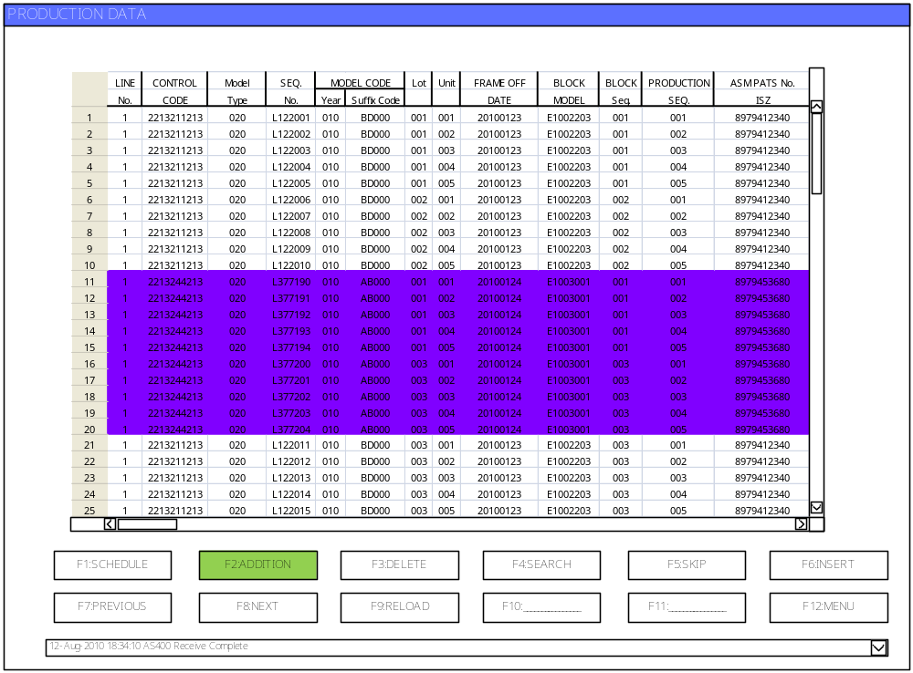
A
＜Figure1･2･7＞

A : The color shown will depend on whether you selected ALL, CAB or PUBX in the ADDITION screen.
- F1：MASS
- F2：PILOT
- F3：EMERGENCY
- F4：SERVICE
1
- F5：CSO

Caution: You cannot use the INSERT feature to insert data into an area with existing instructions.

- F4 SEARCH
Used to search for specific data. (Enter the search conditions and click the Execution button) ＜Figure1･2･8＞
The search key will be the MODEL CODE and the search results will be displayed in the data list shown in ＜Figure1･2･1＞. Use the cursor to navigate around the search results.
Hold down the [EXECUTION] button to execute the search.
A warning message will be displayed if no data matches the search conditions.
Hold down the [CANCEL] button to return to the screen shown in＜Figure1･2･1＞.

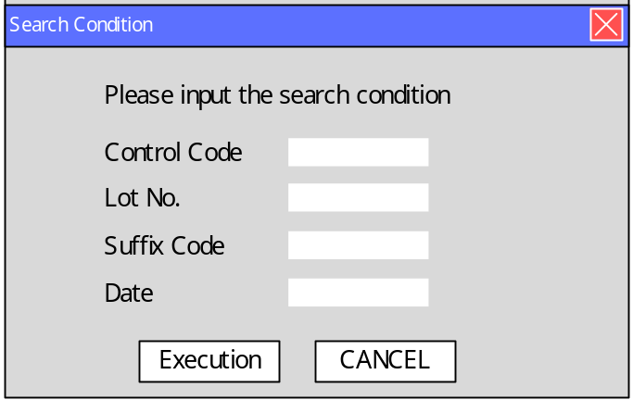
1
1
＜Figure1･2･8＞

If there is more than one, place your cursor on the first one.

- F5 SKIP
Used to skip the production schedule.
It is used to suspend production and extract items from the schedule.
Select items from the PRODUCTION DATA screen using the cursor and click the [F5: SKIP] button.
You can choose to skip items by lot or select a specific line from the list.
When choosing items by lot, the block you have selected will be displayed.

It is possible to skip by the lot unit, the unit of Suffix Code, and the unit of UNIT.
1
1
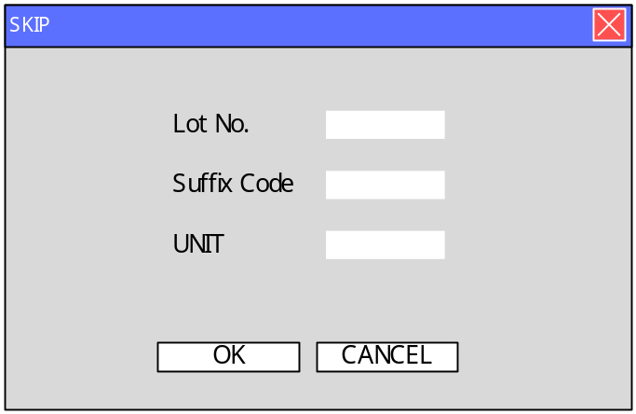
D
E

＜Figure1･2･9＞

When D is pushed, the confirmation screen < Figure 1･2･11> of data is displayed.
1
Once this process is complete, the data you have selected to be skipped will be moved to the holding area and will be deleted from the PRODUCTION DATA list.
Only data for which work has not yet begun can be extracted.
It is necessary to check all lines, and if instructions have been issued to even one line it will not be possible to execute a SKIP.
All changes will be immediately reflected in the production schedule.

It returns to < Figure 1･2･1> when E is pushed.
1

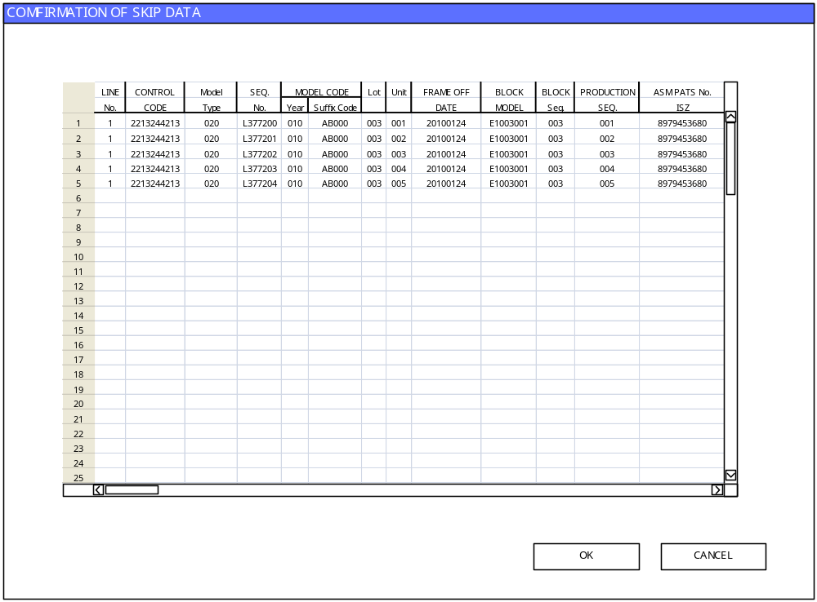
＜Figure1･2･11＞

- F6 INSERT
Used to insert a schedule from currently suspended list of schedules into the Production Data list.
As in the SKIP process, operators must check all lines to confirm that no work is in progress before inserting a schedule into the list.

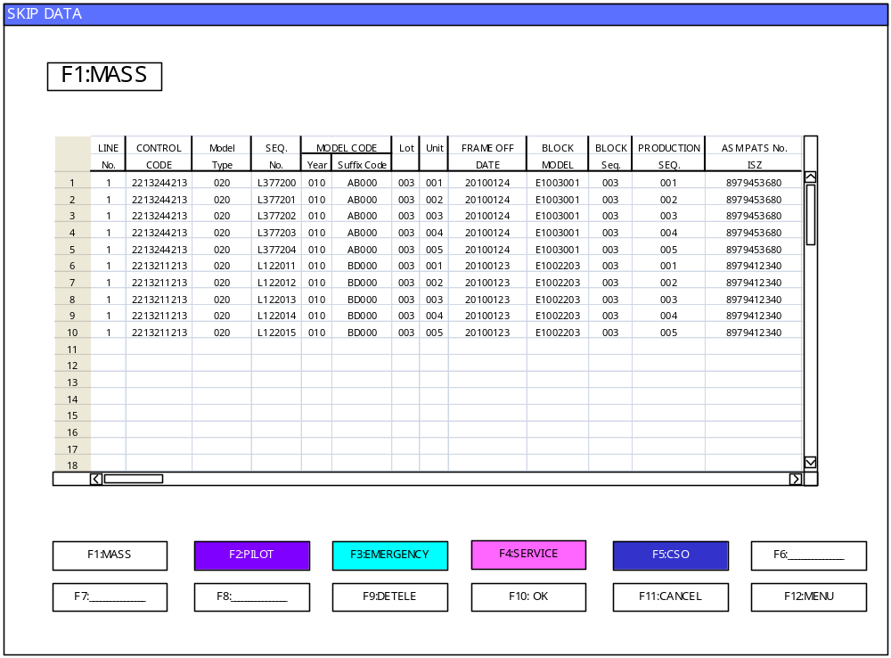
＜Figure1･2･12＞
Ｆ
G
H

F：DELETE
Used to delete a schedule from the SKIP holding area.
If a Lot No. /Part has been selected, the entire Lot will be deleted.
1
When “F:DELETE" is pushed, the confirmation screen < Figure 1･2･12> is displayed.
After "User Name" and "Password" are input and OK is pushed, data is deleted.
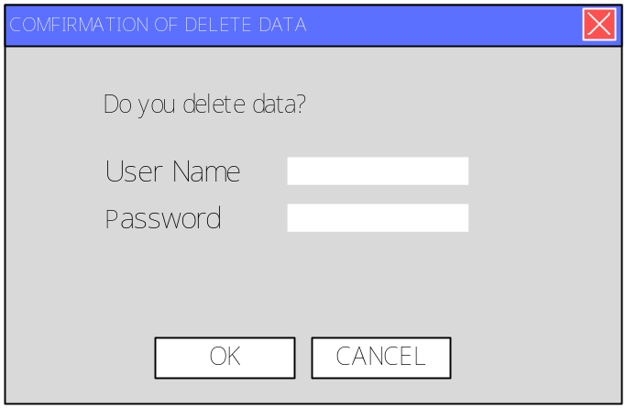
1
＜図1･2･12＞
G：OK
Used to return data from the SKIP holding area back to the PRODUCTION DATA LIST shown in <Figure 1･2･1>. All data selected using the cursor will be returned to the list. If a Lot No. has been selected, the entire Lot will be returned to the list.
H：CANCEL
Used to cancel the request and return to the PRODUCTION DATA list shown in ＜Figure1･2･1＞.

As in the SKIP process, data may be inserted by selecting Lot No. Part or Selected Parts. Once this process is complete, the data you have selected will be deleted from the holding area. A warning message will be displayed when work is in progress. Changes will be immediately reflected on the shared SKIP/INSERT screen.
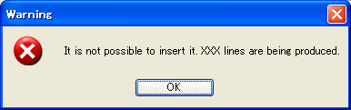
＜Figure1･2･13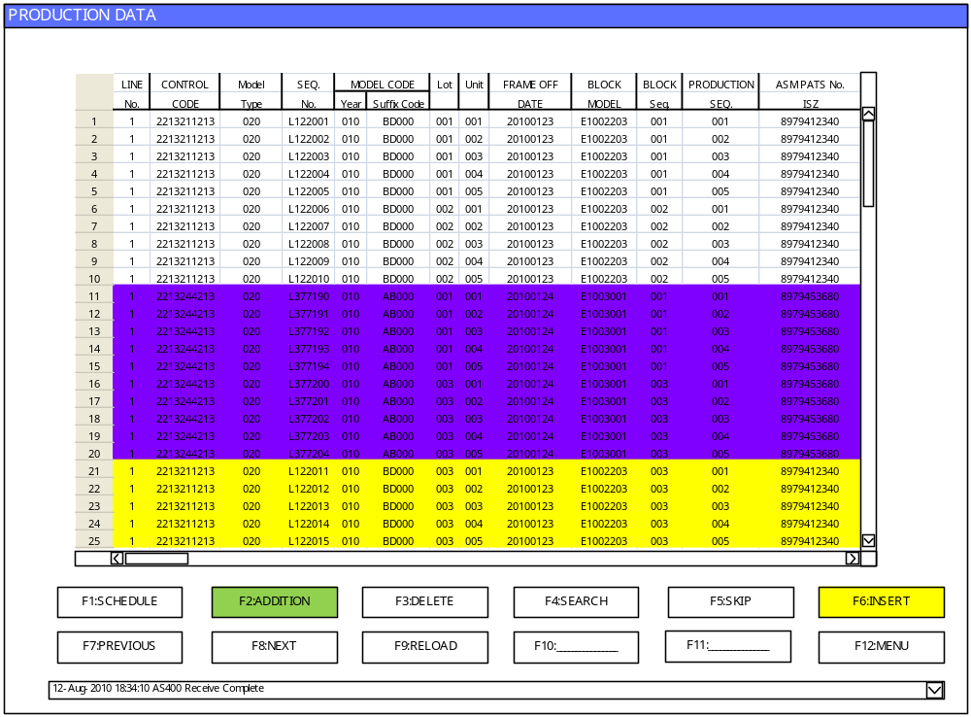＞
＜Figure1･2･15＞
Ｉ
1

I: Schedules inserted from the holding area using the INSERT feature will be displayed in yellow.
Caution: When executing SKIP after ADDITION etc, it will be color coded in accordance with the last executed process.

- F7 PREVIOUS
Used to display previous production data. (will scroll one page back to display the previous page)

- F8 NEXT
Used to display the next page of production data. (will scroll one page forward to display the next page)

- F9 RELOAD
Used to rewrite data. (update to the latest data)

- F12 MENU
It returns to the main menu screen.

F2:INSTRUCTION SCHDULE
The schedule of the production instruction is displayed, and edited by the unit of the module line.
2
3
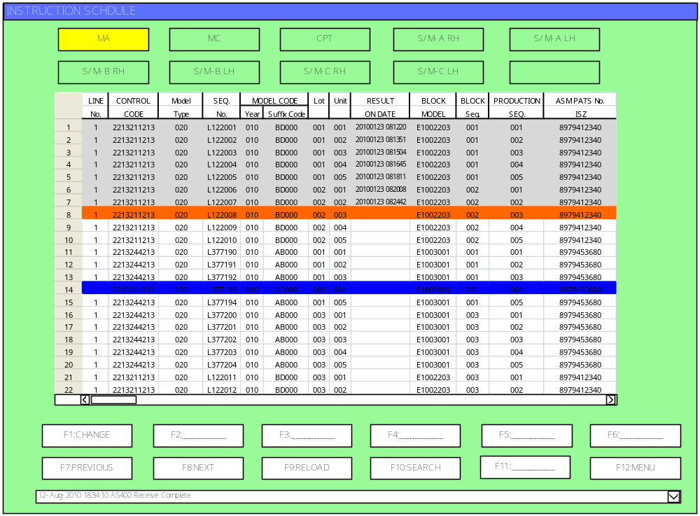 ＜Figure1･3･1＞
4
5
6
7
8
9
１
1
Result data (format: YYYY/MM/DD HH:mm:SS）displays the Weld ON / Line OFF time (registration).
Display directed data + ON / OFF Time.
Data is color coded as follows
Data (line) next in the schedule for production is colored in orange
The current position of the cursor is colored in blue
Data for which instructions have already been issued in colored in grey

The cursor can be moved by using the arrow keys.
The screen will display all the data in the database. The initial display will present data next in the schedule for production towards the center of the screen.

- Module line selection
Used to select individual lines. The selected line will be displayed in yellow.

- F1 CHANGE
Select a row and click the F1 button to move the pointer to that position.
(The current position of the cursor will be displayed in orange.)
When the pointer is moved down, rows between its initial and final position will be displayed in grey.

- F3 EDIT
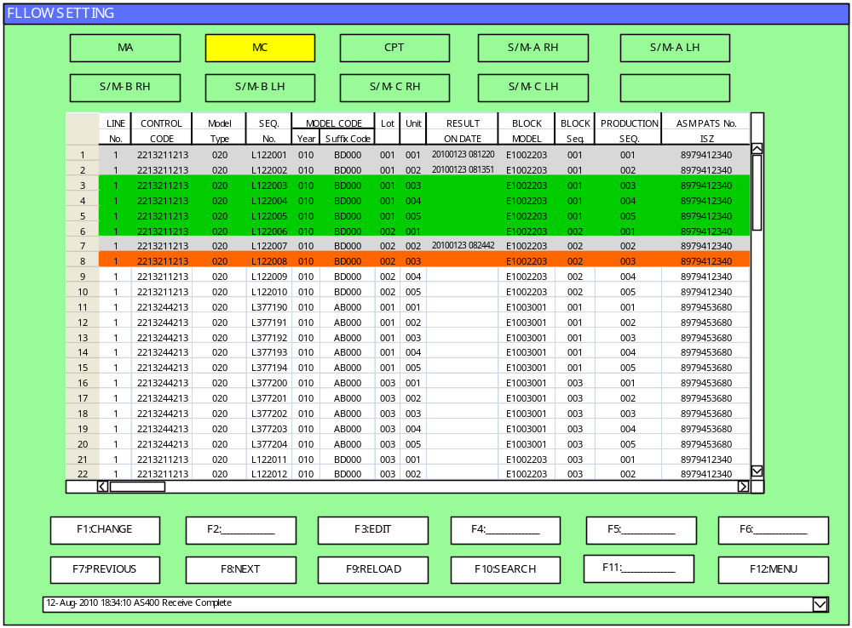"EDIT" makes data to transmit results data to AS400 forcibly when the production results that production instructions system is "NO USE" are not recorded.
There are no results “ON Date Time”
Selection area
＜Figure1･3･2＞

1)The range to put the turning on results data is selected.
2)F3:EDIT is pushed. ＜Figure1･3･3＞ is displayed.

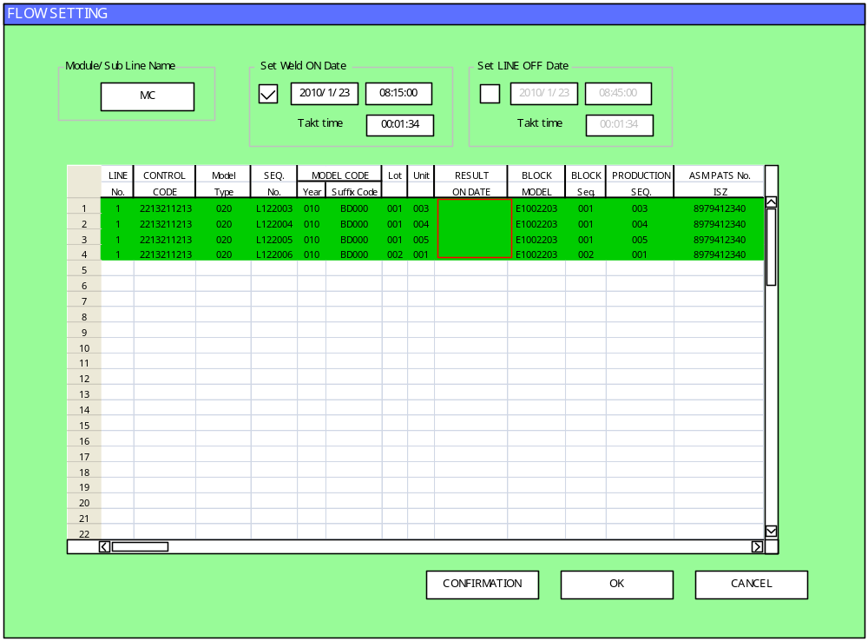
A
B
C
D
E
1
＜Figure1･3･3＞
A Set Weld ON Date
Set the start time of Weld ON.
1
1
B Set LINE OFF Date (Only CPT Line)
Set the start time of LINE OFF.
C CONFIRMATION
Confirm RESULT ON / OFF DATE.
D OK
RESULT ON/ OFF DATE is decided.
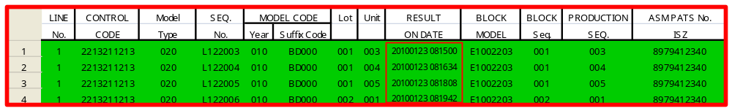
＜Figure1･3･4＞
E CANCEL
Use the CANCEL button to return to the INSTRUCTION SCHEDULE.

- F7 PREVIOUS
Used to display previous production data. (will scroll one page back to display the previous page)

- F8 NEXT
Used to display the next page of production data. (will scroll one page forward to display the next page)

- F9 RELOAD
Used to rewrite data. (update to the latest data)

- F10 SEARCH
Used to search for specific data. (Enter the search conditions and click the Execution button)
A search dialogue box identical to that shown in <Figure 1･3･9> will open.
- F12 MENU
Used to return to the main menu.

- Error message display window:
Displays a log of the last 30 error messages.

- Previous screen button
Used to move to the previous screen. (moves to the screen displaying the remaining line data)
Displays line data from the top left.

- Next screen button
Used to move to the next screen. (moves to the screen displaying the remaining line data)
Displays line data from the top left.
Color Coding
Color coding on the PRODUCTION DATA screen
- ADDTION
- INSERT
Data that has been through the above processes will be appear color coded on the PRODUCTION DATA screen.
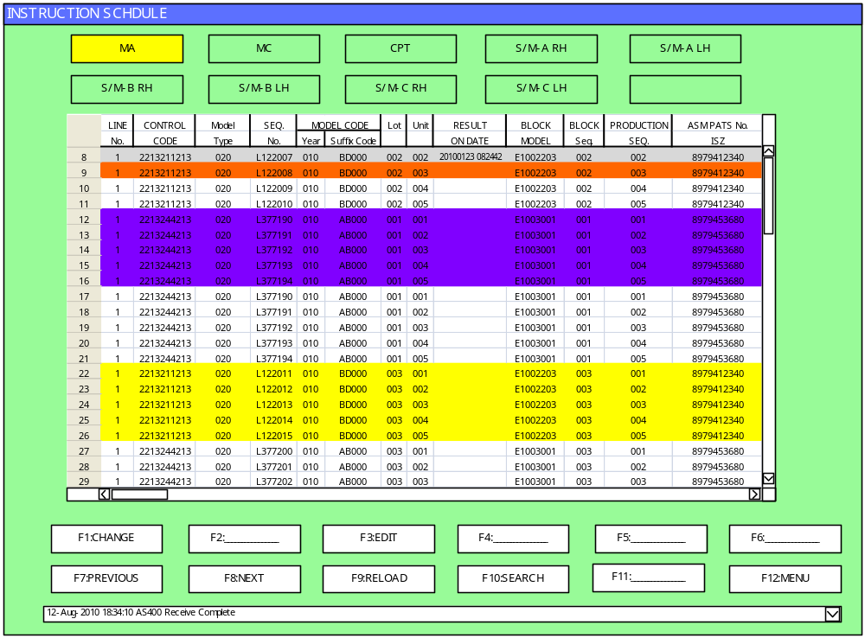
＜Figure1･3･5＞

F3:FLOW SETTING
The flow of the production order of each module line is decided.
1
1
1
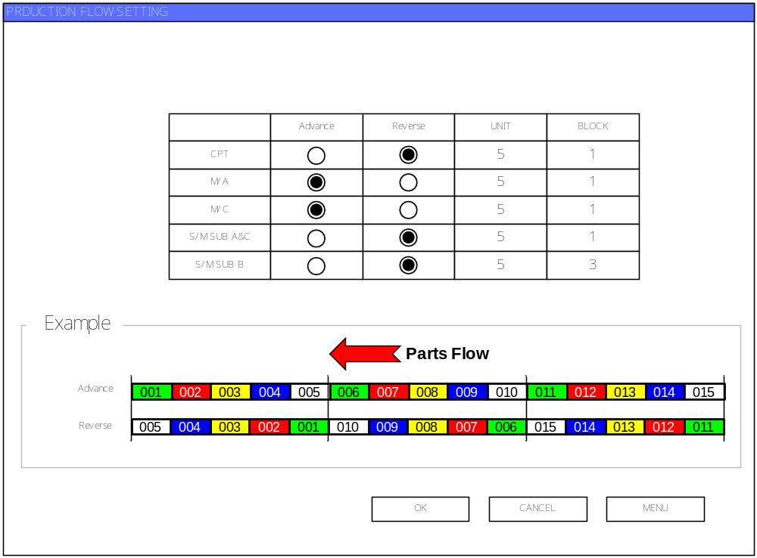
A
1
1
B
C
1
2
3

＜Figure1･4･1＞
A Selection
sereclt“Advance”or“Reverse”
B UNIT
It produces by "How many quantity" and quantity is input.
C BLOCK
It produces by "How many Unit" and quantity of Unit is input.

- OK
Used to OK button to fixe.
- CANCEL
Used to CANCEL button to interrupt processing.
- MENU
Use the MENU button to return to the main menu.

F5: DATA LOG
Used to display log data.
It is possible to display the following logs.
- AS400 LOG
- PLC LOG
- Operation LOG
Log data is stored in the database for 30 days. (can be changed using INI files)
The first log to be displayed is the AS400 LOG.
1
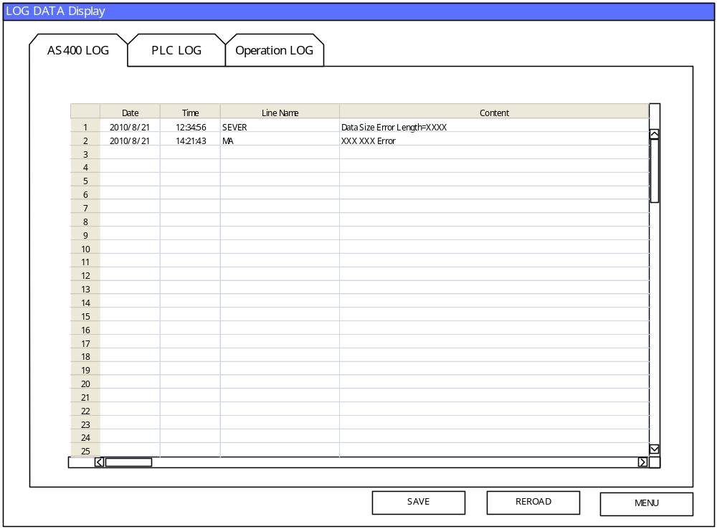
2
3
4
1
1

＜Figure1･5･1＞
  - Switching between log displays
Use the tabs to switch between the log displays.
  - SAVE
Use the SAVE button to save log data.
  - RELOAD (update)
Use the RELOAD button to obtain and display the latest log data.
  - CANCEL
Use the CANCEL button to return to the main menu.
The data communication log allows you to view data sent from the host computer (AS400) and data sent to the PLC.
Data will be stored for a period of two weeks (default).
These settings can be changed using the INI files.

The AS400 data log will contain

- Date/time data was sent
- Name of the sent file
- Path (name of the path to the original data)
- OK/NG information
- Number of files sent

When you delete data from the log, the original data will also be deleted.

Caution: The AS400 data communication log will also record normally received data.

Figure 7.6.2 shows the PLC data communication LOG screen
Figure 7.6.3 shows the operation LOG screen
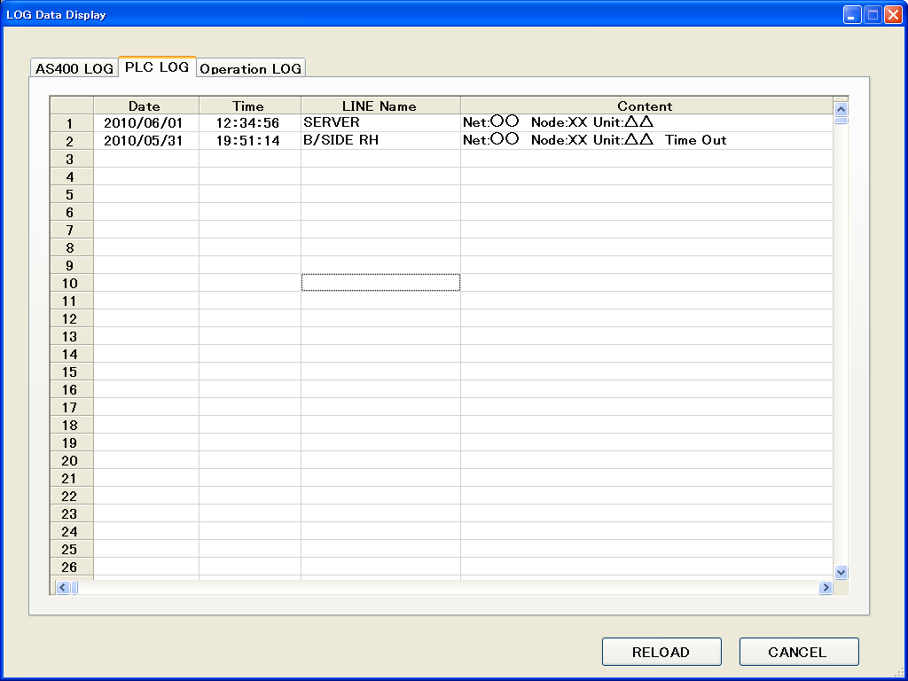
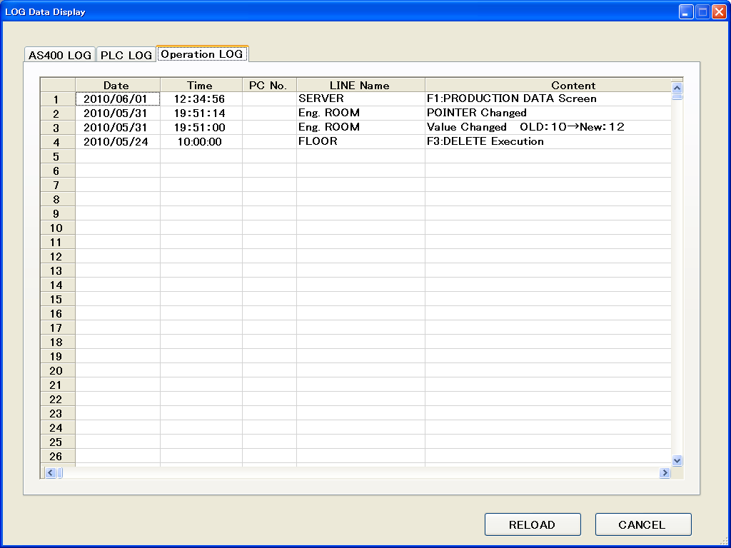
1
1
＜Figure1･5･2＞ ＜Figure1･5･3＞

F12: SHUT DOWN

Used to shut down the program.
It is also possible to select to shut down the OS.

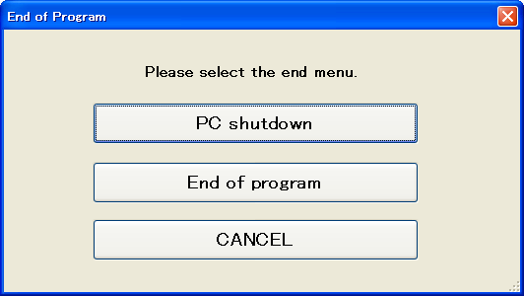

1
2
3

＜Figure1･6･1＞

- PC shutdown
Used to shut down the program and turn off power to the computer terminal.

- End of program
Used to shut down the program.

- CANCEL
Used to return to the main menu.

Data Collection
The data collection program configuration is shown below.

Configuration
Divided primarily into the display screen and the data collection process.

＜Figure2･1･1＞
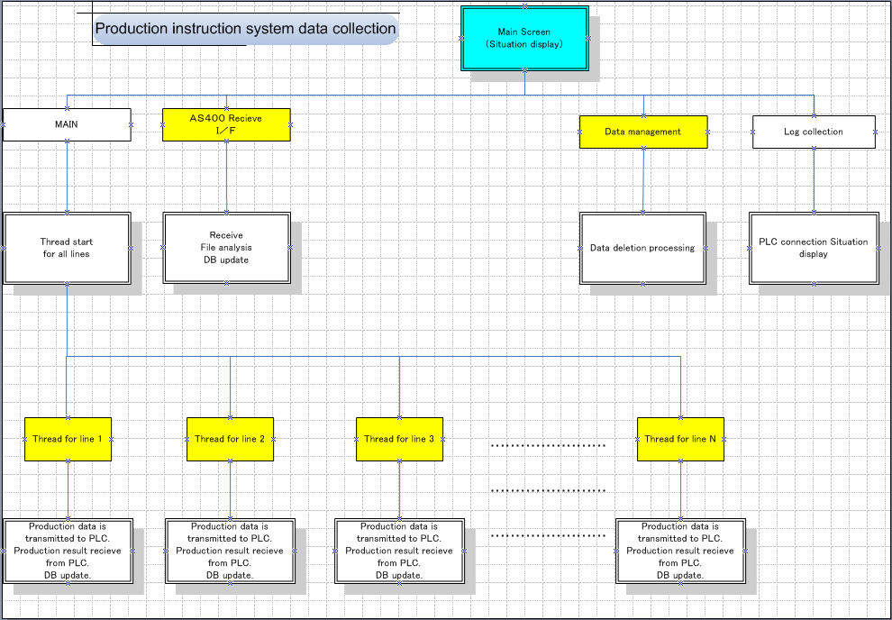
Blue: Screen
Yellow: Thread

PLC Data Communication Area Map
Please refer to separate material.

Database Configuration
Data sent from the host computer (AS400) will be stored in the database.
Please refer to separate material for detailed information on the database.

Error Processing
A designated number of retries will be established for data delivery/receipt errors.
The number of retries can be changed using the INI files.

AS400 Data Receipt
Data will be stored in the database following receipt using HULFT software.
Received files will not be deleted and will be stored for a designated period.
If the Lot No. + Unit + MODEL CODE are the same overwrite the data and rearrange the order of the data by Production Day + SEQ. No.
(Data will be displayed as Order by)

Data Collection Main Screen
The data collection screen is shown below.
This program is run on the server.
１
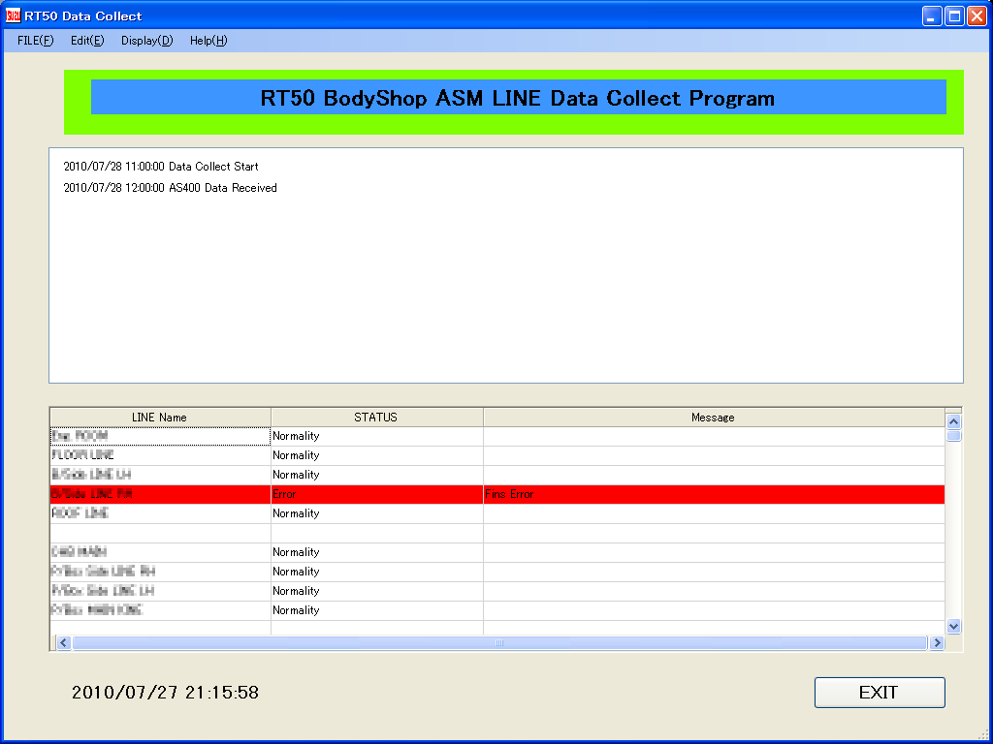
2
3
4
RT50 Frame Shop ASM Line Data Collect Program
＜Figure2･6･1＞

- Display Area
This area enables operators to check data that has been received from AS400 in real time. The maximum number of data that can be displayed in this area can be set in the INI files. (Default 200 lines of data)
- ASM LINE Connection Status
Enables operators to check the connection status of each line.
- Date/Time Display
Shows the current date and time.
- EXIT Button
Used to shut down the data collection program.

